Supplementary Material S4: mSEC-AM audit method and effectiveness verification.
This supplement expands Section 2.3 of the main manuscript and provides the full definition of mSEC-AM, including artifacts, participants, stages, and the CI/CD workflow architecture that operationalizes the method. It also specifies how evidence is produced, packaged, and traced to requirements and outcomes.

S4.1 Positioning versus assurance reporting frameworks
To enhance stakeholder assurance, several certification and reporting frameworks address the role of information technology in risk management and assurance processes [1]. Among the most widely adopted are the Systems and Organization Controls (SOC) reports issued by the AICPA, including: SOC 1, focused on internal control over financial reporting (ICFR) [1]; SOC 2, offering insights and pledge about the protection of privacy, processing fidelity, security, availability and confidentiality standards in a service provide [2]; and SOC 3, akin to SOC 2, possesses a lesser degree of comprehensiveness and is aimed at general use, thereby facilitating unrestricted distribution [3]. A variety of tools have been introduced to facilitate SOC compliance, including Secureframe, Vanta, Strike Graph, Drata, AuditBoard , and Tugboat Logic.

Unlike assurance instruments that primarily emphasize organizational controls and documentary evidence, our specification-driven methodology treats security verification as technical validation that is executable within CI/CD and repeatable per software version and increment. The approach is grounded on SECM-CAT, a reusable catalog of mHealth security requirements implemented as a security requirements specification, which enables precise audit tailoring by selecting and prioritizing requirements according to context and software changes, refining verifiable criteria, and evolving the catalog as standards and guidelines evolve. This orientation enforces explicit traceability from requirement to evidence to outcome and supports defensible compliance claims through versioned, run-level evidence suitable for external audits.

S4.2 Overview of mSEC-AM
mSEC-AM is an audit approach specifically designed for mHealth applications, which is objective, usable, agile, systematic, and repeatable. mSEC-AM complements and extends related methodologies reported in the literature [4], [5], [6], [7], by operationally integrating into DevSecOps to align assessment throughout the software lifecycle. The approach is grounded on SECM-CAT, a reusable catalog of mHealth security requirements implemented as a security requirements specification. SECM-CAT enables precise audit tailoring by selecting and prioritizing requirements according to context and software changes, refining verifiable criteria, and evolving the catalog as standards and guidelines evolve.

Based on the CISA standard structure, the method strengthens Domain 1 [8], Information Systems Audit Process, by optimizing planning and execution through: i) a contextual assessment that defines scope, attack surface, impacted functionalities, and relevant risks, and ii) the generation of SECM-CAT*, a customized checklist derived from the base SRS that contains only applicable and verifiable requirements for the evaluated increment.

From SECM-CAT*, the audit is integrated into CI/CD pipelines, supported by technical validations with specialized external tools for static and dynamic analysis, collecting evidence by execution, recording configuration and execution responsibilities, and autonomously correlating findings with requirements. This design supports a controlled hybrid approach: automatable results are backed up by pipeline evidence, while non-automatable findings must be corroborated with a manual audit containing complementary inputs and evidence, preserving methodological consistency.

The result is the automated and systematic generation of audit artifacts ready for technical and executive use, including compliance matrices, traceability of requirements, findings, and evidence, technical reports, and executive summaries assisted by LLMs and AI. These are applied to the pipeline results and evidence to accelerate early delivery of secure software, classification and synthesis, support remediation recommendations, and standardize deliverables, reducing manual effort and variability between audits without replacing the underlying technical evidence. The coordination between roles, decisions, and deliverables, along with the flow of remediation, revalidation, and closure of findings, is detailed in Figure S4.1.

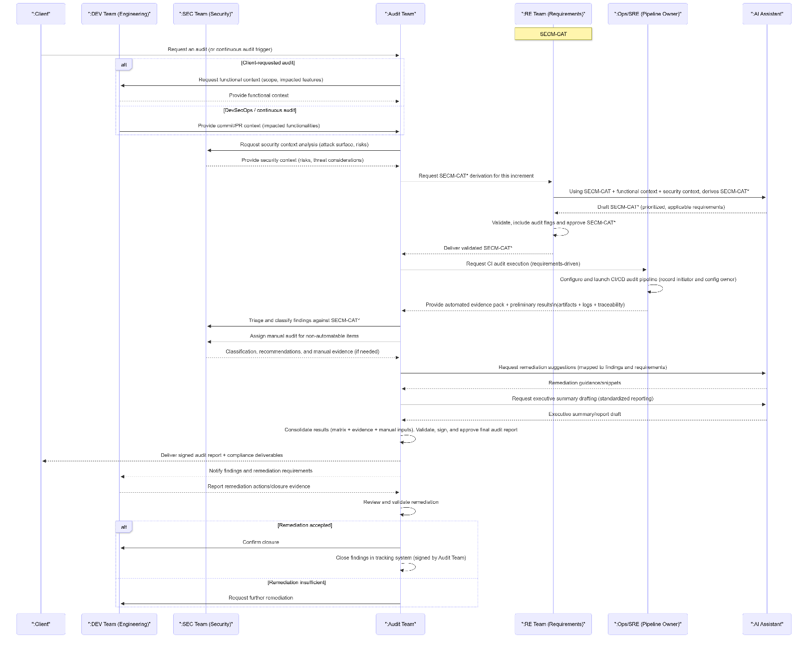
Figure S4.1. Mobile Security Audit Method, mSEC-AM

S4.3 Components and artifacts of mSEC-AM

mSEC-AM generates the following artifacts:

- SECM-CAT: Reusable catalog of security requirements for mobile applications and baseline for the audit procedure. It is implemented as a Security Requirements Specification (SRS) with verifiable and traceable requirements derived from standards, guidelines, regulations, and academic literature. It is used to define and prioritize evaluation criteria, correlate findings with requirements, and support the generation of audit evidence and artifacts.
- SECM-CAT*: Adapted version of SECM-CAT, generated for the evaluated application and increment. It selects and prioritizes only the applicable requirements according to the context and software changes, preserving the attributes, traceability, and verification criteria of the base catalog.
- Audit checklist: Document derived from SECM-CAT* that consolidates the requirements to be evaluated in the mHealth application. It can adopt the most convenient format for the audited software, for example, a spreadsheet, online form, or other electronic or printed medium. In this work, the checklist is presented in Excel format.
- Audit summary: Final deliverable that synthesizes, for executive and technical use, the results of the continuous audit workflow. It describes the scope and conditions of the evaluation, consolidates applicability and compliance metrics, and prioritizes findings according to severity and prevalence. It includes remediation triage with responsible parties, acceptance criteria, and an action plan for follow-up, revalidation, and closure, maintaining traceability with the SECM-CAT* list and its supporting evidence to substantiate decisions and external audits.
- CI/CD Workflow Artifacts: Pipeline configuration files scripts and parameters that allow the audit to be reproduced and demonstrate how the validations were executed and the artifacts generated. This includes, but is not limited to, the files and scripts necessary for the configuration of tasks, steps, and orchestration models used in automation.
- Evidence Pack: A consolidated set of technical evidence produced by the pipeline, supporting the determinations in the checklist and audit summary. It includes, as applicable, outputs from static and dynamic analysis tools, execution logs, version and execution metadata, and requirement-finding-evidence traceability records.

S4.4 Participants of mSEC-AM
The methodology involves the following stakeholders:

- Client: The entity or requester that requires an audit to evaluate the security attributes of an mHealth application, defines the evaluation needs, and receives the signed deliverables.
- Development Team (DEV): Responsible for the design and implementation of the mHealth software. They provide the functional and change context, such as the scope and affected functionalities, commits or pull requests, and execute remediation actions.
- Security Team (SEC): Responsible for providing analysis of the application's security context, including the attack surface, risks, and threat considerations; reviews configurations and controls; and supports the interpretation and technical validation of the findings.
- Audit Team (AT): Leads the audit, requests and validates inputs, classifies and consolidates findings according to the SECM-CAT* standard, determines compliance with requirements, validates evidence, signs the final report, and verifies remediation until closure.
- Requirements Team (RE): Responsible for maintaining SECM-CAT and deriving SECM-CAT* for the evaluated increment. Selects and prioritizes requirements according to the functional and security context and incorporates the necessary parameters and checkmarks.
- Operations/SRE Team, Pipeline Owner: Responsible for configuring, signing, and executing the audit-oriented CI/CD pipeline; integrating static and dynamic analysis tools; managing credentials and the execution environment; publishing artifacts; and preserving traceability of executions, including the initiator, the configuration owner, logs, and evidence.
- AI Assistant: An integrated component in the API that facilitates specific workflow tasks, such as synthesizing and standardizing deliverables, assisting with classification and triage, and generating remediation guides based on findings and requirements. Its outputs are auxiliary and must be validated by the Audit Team and, where applicable, by the Security Team.

S4.5 Stages and actions of mSEC-AM
mSEC-AM defines an AI-assisted continuous audit procedure for mHealth applications, integrated into a DevSecOps approach. The process is organized into five sequential stages that allow for defining the scope, deriving verifiable criteria from SECM-CAT, executing reproducible technical validations, and producing auditable deliverables with traceability from requirement to evidence to outcome:
- Contextual Assessment: The Development (DEV) team characterizes the functional context of the mHealth application selected for auditing. This characterization includes background information, user profiles, scope, environmental factors, product objectives, and other operational conditions that affect the expected system behavior. Based on this context, the Security (SEC) team defines the security context, delimits the attack surface, assesses potential risks, and specifies expected configurations and controls that will serve as a reference for the assessment.
- SECM-CAT* creation: The Requirements (RE) team, considering the contextual assessment defined in the previous stage, derives SECM-CAT* as an adapted version of the base SECM-CAT catalog. SECM-CAT* selects and prioritizes only the applicable and verifiable requirements for the evaluated application and increment, preserving attributes, verification criteria, and traceability, and incorporating the necessary parameters and flags for validation.
- Checklist Development: The Audit team (AT) builds the operational checklist based on SECM-CAT*. This checklist explicitly states, for each requirement, the decision criteria and the required evidence, and acts as a control instrument to ensure consistency, repeatability, and traceability during execution.
- Audit and Vulnerability Analysis Execution: The audit is executed using a CI/CD workflow operated by the Ops/SRE team, which owns the pipeline. This workflow integrates external technical validation tools and produces reproducible evidence per execution. The analysis employed the following techniques:

- SAST, static application security testing, to identify problems in the source code before deployment. [9]
- DAST dynamic application security testing, to evaluate security controls during execution in a controlled test environment. [10], [11].
- IAST Interactive Application Security Testing, to instrument the running application and correlate dynamic observations with the code. [12]
- Manual testing to verify non-automatable or context-dependent requirements [13].

IAST, DAST, and SAST were used in a combined manner, reinforced with manual validation focused on specific requirements, as has been done in previous work due to their complementarity in identifying unsafe practices and vulnerabilities [14], [15], [16].

- Audit document preparation and artifact generation: The Audit team (AT) consolidates the findings derived from the execution, correlates them with SECM-CAT* requirements, and determines compliance for each requirement, preserving the associated evidence. With the support of the integrated AI assistant via the API, the synthesis and standardization of deliverables are automated without replacing the primary evidence generated by the pipeline or the documented manual verifications. At this stage, the compliance checklist, evidence package, and final Audit Summary report are created, including the remediation classification and acceptance criteria, an action plan for follow-up, revalidation, and closure.

S4.6 AI-assisted CI/CD workflow architecture for mHealth security audit
The audit workflow begins at the trigger layer using push events, pull requests, and manual execution. Before executing intensive tasks, it applies trust and execution controls that impose gateways for Dependabot and for pull requests originating from branches, and maintains traceability through concurrency control per pull request or branch.

Execution takes place in GitHub Actions runners and uses Python as the runtime for automation and artifact generation. The workflow integrates external services via APIs, including MobSF for mobile security analysis, and an LLM-based assistant with ChatGPT, GPT-5.4 to support the standardization of deliverables from evidence produced by the pipeline. The AI ​​LLM is configurable for any engine such as Mistral, Azure, OpenAI, Claude, Gemini, etc. For reproducibility, the workflow records tool versions, model identifier, prompts, and run metadata alongside the generated artifacts are available in GitHub repository.

In Phase 1, executed in parallel, technical evidence is collected and inputs are packaged. This phase includes CodeQL analysis for static analysis and SARIF results, security scans to generate dependency reports and normalized payloads, a MobSF scan invoked via API to produce mobile reports, and source code packaging to generate the OpenMRS-zip artifact.

In Phase 2, executed sequentially, the evidence is consolidated and the deliverables are generated. First, the VISION360 generator consolidates the upstream artifacts into a unified fingerprint and an evidence bundle. Then, the Checklist generator uses the fingerprint, and the requirements catalog to produce the compliance checklist in Excel format. Finally, the Audit Summary process is divided into two stages: Stage 1 builds a JSON analysis package with consolidated metrics and evidence references, and Stage 2 generates the final Audit Summary report in docx and pdf format with the support of the AI assistant, preserving traceability to the evidence.

As a result, the workflow publishes primary deliverables and supporting evidence. The primary deliverables include the compliance checklist and the final Audit Summary report in docx and pdf format. Supporting evidence is grouped into an evidence pack for each run, which includes scanner outputs, fingerprints, logs, and provenance metadata, while internal artifacts preserve workflow logs, SARIF, JSON, compressed files, and run metadata for forensic auditing and reproducibility. Figure S4.2 summarizes the workflow architecture for operationalizing mSEC-AM.

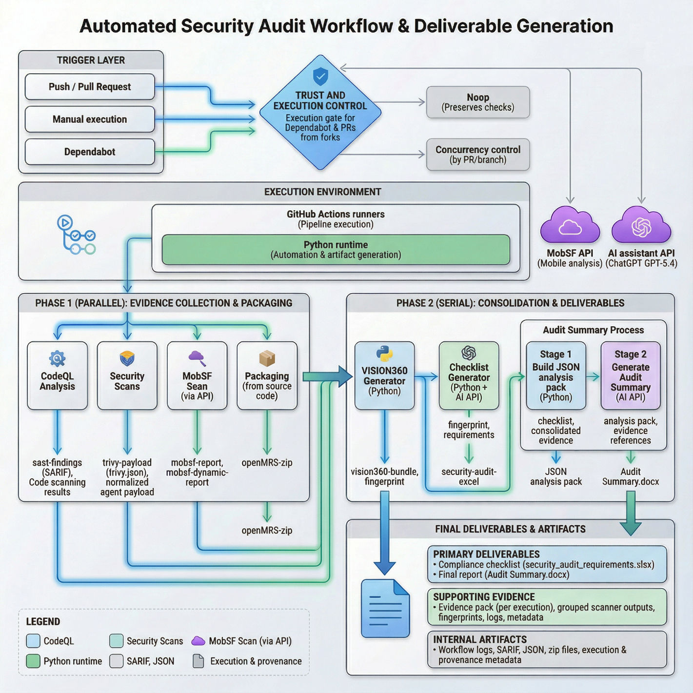

Figure S4.2. AI-assisted CI/CD workflow architecture that operationalizes mSEC-AM

References
[1] T. A. I. of CPAs, “Information for service organization management in a SOC 1® engagement | Resources | AICPA & CIMA,” 2023. [Online]. Available: https://www.aicpa-cima.com/resources/download/information-for-service-organization-management-in-a-soc-1-engagement
[2] T. A. I. of CPAs, “SOC 2® - SOC for Service Organizations: Trust Services Criteria | AICPA & CIMA.” Accessed: Jun. 14, 2024. [Online]. Available: https://www.aicpa-cima.com/topic/audit-assurance/audit-and-assurance-greater-than-soc-2
[3] T. A. I. of CPAs, “AICPA & CIMA.” [Online]. Available: https://www.aicpa-cima.com/topic/audit-assurance/audit-and-assurance-greater-than-soc-3
[4] M. A. Martínez, J. Lasheras, E. Fernández-Medina, A. Toval, and M. Piattini, “A Personal Data Audit Method through Requirements Engineering,” Comput. Stand. Interfaces, vol. 32, no. 4, pp. 166–178, 2010, doi: https://doi.org/10.1016/j.csi.2010.01.001.
[5] M. A. Aguilar, A. Toval, and M. Campos, Requirements Engineering to Audit Privacy Issues in Medical and Health Software. 2008.
[6] B. Cruz Zapata, J. L. Fernández-Alemán, A. Toval, and A. Idri, “Reusable Software Usability Specifications for mHealth Applications,” J. Med. Syst., vol. 42, no. 3, p. 45, 2018, doi: 10.1007/s10916-018-0902-0.
[7] C. M. Mejía-Granda, J. L. Fernández-Alemán, J. M. Carrillo de Gea, and J. A. García-Berná, “A method and validation for auditing e-Health applications based on reusable software security requirements specifications,” Int. J. Med. Inform., vol. 194, p. 105699, 2025, doi: https://doi.org/10.1016/j.ijmedinf.2024.105699.
[8] ISACA, “CISA® Exam Content Outline,” 2026. [Online]. Available: https://www.isaca.org/credentialing/cisa/cisa-exam-content-outline#1
[9] P. Krishnan, C. Cifuentes, L. Li, T. F. Bissyande, and J. Klein, “Why Is Static Application Security Testing Hard to Learn?,” IEEE Secur. Priv., vol. 21, no. 5, pp. 68–72, 2023, doi: 10.1109/MSEC.2023.3287206.
[10] C. Cifuentes, F. Gauthier, B. Hassanshahi, P. Krishnan, and D. McCall, “The role of program analysis in security vulnerability detection: Then and now,” Comput. Secur., vol. 135, 2023, doi: 10.1016/j.cose.2023.103463.
[11] S. Pfeiffer, S. Unger, D. Timmermann, and A. Lehmann, “Secure information flow awareness for smart wireless eHealth systems,” in International Multi-Conference on Systems, Signals and Devices, SSD 2012 - Summary Proceedings, 2012. doi: 10.1109/SSD.2012.6198123.
[12] F. M. Tudela, J. R. B. Higuera, J. B. Higuera, J. A. S. Montalvo, and M. I. Argyros, “On Combining Static, Dynamic and Interactive Analysis Security Testing Tools to Improve OWASP Top Ten Security Vulnerability Detection in Web Applications,” APPLIED SCIENCES-BASEL, vol. 10, no. 24, 2020, doi: 10.3390/app10249119.
[13] V. Casola, A. De Benedictis, C. Mazzocca, and V. Orbinato, “Secure software development and testing: A model-based methodology,” Comput. Secur., vol. 137, p. 103639, 2024, doi: https://doi.org/10.1016/j.cose.2023.103639.
[14] A. Nguyen-Duc, M. V. Do, Q. Luong Hong, K. Nguyen Khac, and A. Nguyen Quang, “On the adoption of static analysis for software security assessment–A case study of an open-source e-government project,” Comput. Secur., vol. 111, p. 102470, 2021, doi: https://doi.org/10.1016/j.cose.2021.102470.
[15] C. M. Mejía-Granda, “Desarrollo de servicios web REST ‘inseguros’ para auto-aprendizaje en la explotación de vulnerabilidades,” Jul. 2018, Accessed: Mar. 28, 2023. [Online]. Available: https://reunir.unir.net/handle/123456789/7435
[16] V. Somi, “A Comparative Analysis and Benchmarking of Dynamic Application Security Testing (DAST) Tools,” Journal of Engineering and Applied Sciences Technology, pp. 1–6, Feb. 2024, doi: 10.47363/JEAST/2024(6)E139.

https://secureframe.com/
https://www.vanta.com/demo
https://www.strikegraph.com/
https://drata.com/
https://www.auditboard.com/
https://tugboatlogic.com/
https://url-shortener.me/CGLV
https://url-shortener.me/CGXM
https://url-shortener.me/CH0H
https://url-shortener.me/CH1I
https://url-shortener.me/CGYE
https://url-shortener.me/CGZA
https://url-shortener.me/K9FZ
https://url-shortener.me/CH3V
https://url-shortener.me/CH7G
https://url-shortener.me/CH7P
https://url-shortener.me/CMQF
https://url-shortener.me/AEDV

